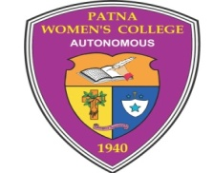

**PATNA WOMEN’S COLLEGE (AUTONOMOUS)**

**PATNA UNIVERSITY**

**3rd Cycle NAAC Accredited at ‘A’ Grade with CGPA 3.58/4**

**“College with Potential for Excellence” (CPE) Status Accorded by UGC**

**YEAR OF ESTABLISHMENT: 1940**

**Session – 2023-24**

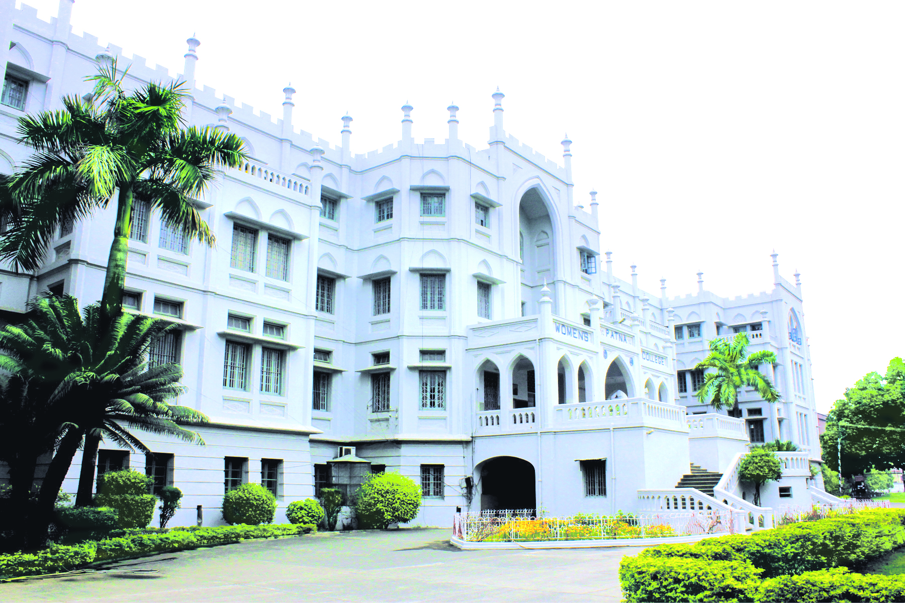

Admission & Online Admission Form related query please email us at [info@patnawomenscollege.in](mailto:info@patnawomenscollege.in) or call us at 0612-2531186 (09:00 am to 03:00pm)

Online Admission Form (Technical) & Fees Payment query please email us at support@finessewebtech.com or call us at 0612-2524388 (09:00 am to 03:00pm)

For more information please visit www.patnawomenscollege.in



Foundress of the Apostolic Carmel Congregation

Mother Veronica (Miss Sophie Leeves, born on October 1, 1823), Foundress of the Sisters of the Apostolic Carmel, Mangalore, Karnataka, India, was deeply religious and highly intellectual, an English woman attracted by Christ, gave her entire life to God. In 1868 the Apostolic Carmel was established in Bayonne, France, and in 1870, in India. Her mission was to educate and empower the women in India.

About the College

**PATNA WOMEN’S COLLEGE (Autonomous)** established in 1940, is the first institution of higher learning opened to cater to the educational needs of women in Bihar. Bishop B.J. Sullivan S.J., Bishop of Patna (Founder) and Mother M. Josephine A.C. Superior General of the Apostolic Carmel named it Patna Women’s College and presented it as a gift to the Women of Bihar, thereby placing at their disposal an opportunity for higher education. The College is run by the Catholic Religious Sisters of the Apostolic Carmel, an indigenous educational body founded in 1870.

The College was granted the status of Degree College in July 1941.In the year 1952, a Special Status was given by the Government of Bihar and it became a ‘Constituent College’ of Patna University. On 25.07.2007, the Government of Bihar, officially declared Patna Women’s College as a ‘Religious Minority College’.

The College whose hallmark has always been Quality and Excellence, has been accredited by NAAC with ‘A’ grade for three consecutive cycles with CGPA 3.51/4 in 2010 and CGPA 3.58/4 in 2015. The college also has been accorded as ‘College with Potential for Excellence (CPE)’ status from UGC in three phases in 2004, 2010 and 2015. The University Grants Commission (UGC) has conferred Autonomous status to Patna Women’s College in January, 2018.

The College forges ahead to face the challenge of 21st Century, explosion of information, management of knowledge, integration of Information and Communication Technology (ICT) with education, curriculum innovation and curriculum reforms. This also includes establishing synergic partnership with industries, HEIs and R & D Organizations, developing a Research Centre and creating and enterprising spirit in students.

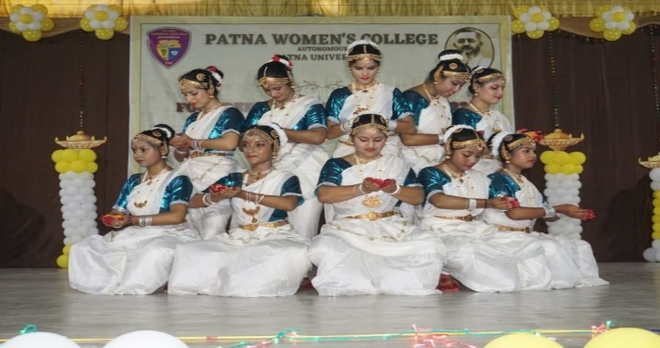

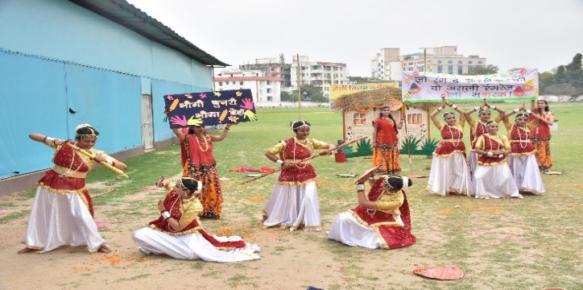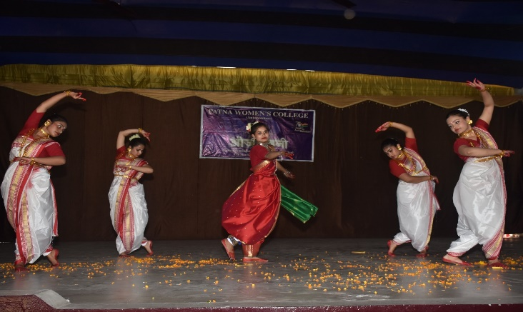

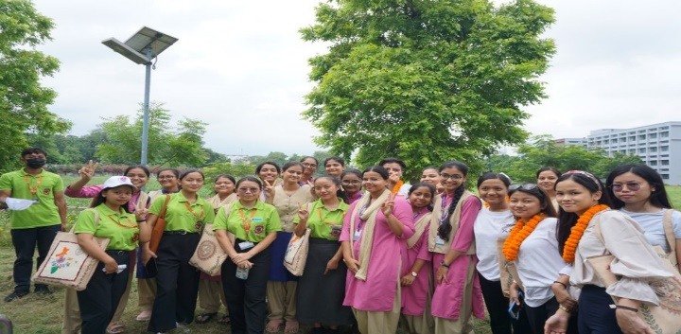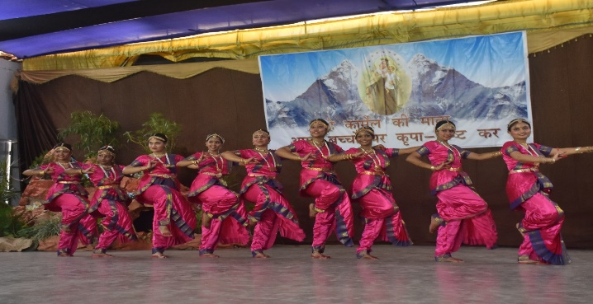

– Faith in God

– Honesty / Moral Uprightness

– Love and Forgiveness towards all

– Social Responsibility / empowerment of the Marginalized

– Respect for Life and Creation

– Pursuit of Excellence

– Promotion of peace and harmony

Core Values

**Core Values**

Mission

Patna Women’s College, the first College for women in Bihar, is committed to the holistic development of women so as to make an effective contribution to the creation of a new society. To this end we strive -

• To become a centre of excellence in Higher Education for Women in an atmosphere of autonomy

• To excel in teaching-learning, research and consultancy

• To provide education that promotes holistic development of a person

• To offer subjects for competency building and motivate/animate a work force imbued with human values

• To promote patriotism, communal harmony and cultural integration to maintain a free and peaceful atmosphere in the campus

• To train the students in creative arts, social service, critical thinking, and leadership in order to make an effective contribution to the creation of a new and value based society

• To create women leaders and to make them agents of social change

• To develop skill oriented and value based courses, for the all-round development of individuals

• To promote academic exchange and academia-industry interface

• To form young women who are ‘always wise’ and who will dare to ‘go ahead and conquer knowledge’ through, competence,

commitment, delicate conscience and compassion

Rooted in the life, Mission and teachings of Jesus Christ and inspired by Mother Veronica, the Foundress of the Apostolic Carmel, Patna Women’s College strives to become a centre of academic excellence in Higher Education, Social responsibility, and Empowerment of Women.

Vision



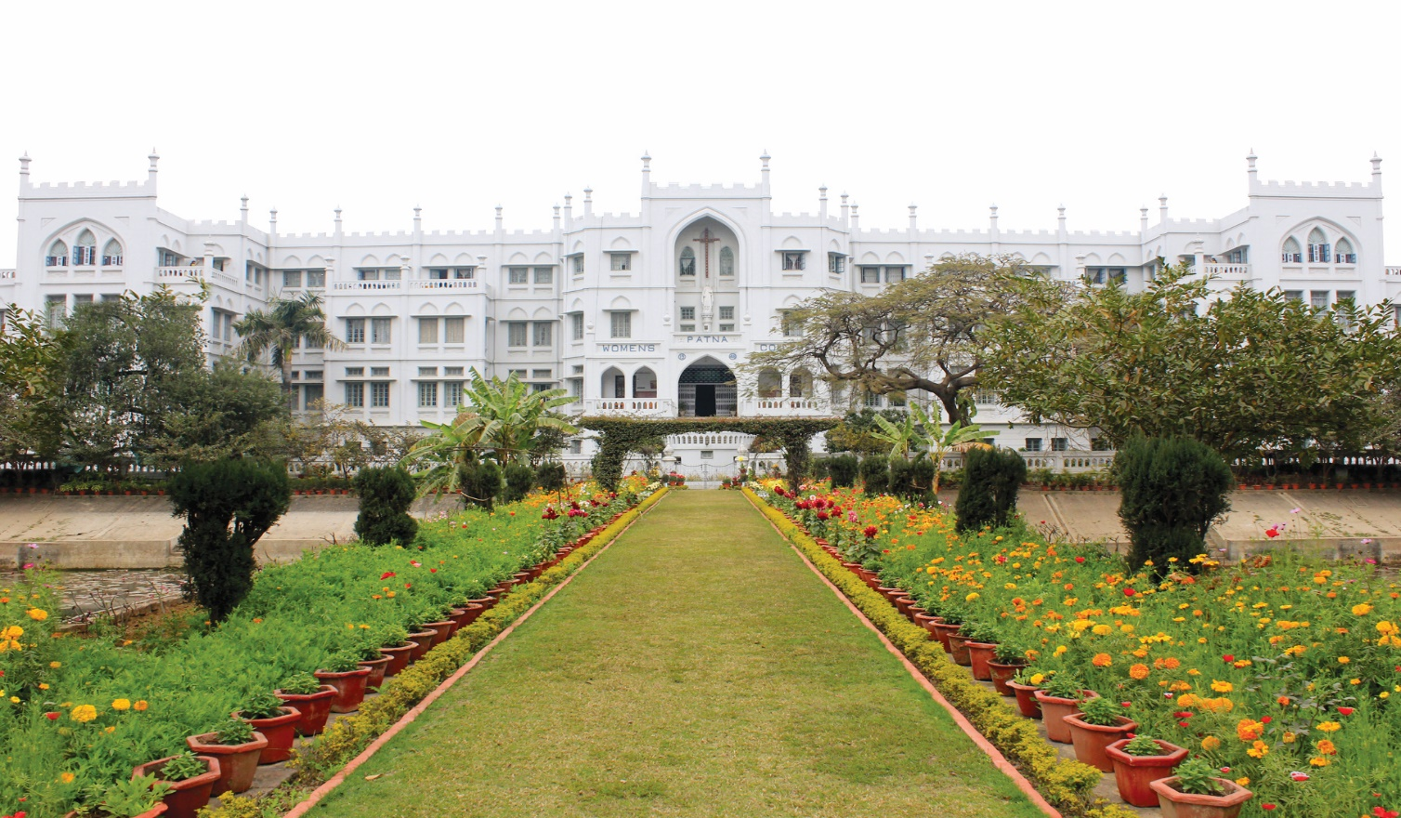

**PATNA WOMEN’S COLLEGE MAIN BLOCK**

**Core Values**

**ACADEMIC PROGRAMME**

**Three Year B.A. / B.Sc. / B.Com. Honours**

**SCIENCE**

**HUMANITIES**

**COMMERCE**

**SOCIAL SCIENCES IES**

• Economics

• Geography

• History

• Sociology

• Psychology

• Political Science

• Home Science

•Communicative English and

Media Studies

• Mass Communication

• Physics

• Chemistry

• Botany

• Zoology

• Mathematics

• Statistics

• Microbiology

•Computer Applications

(B.Sc.)

• Accounting and Finance

• Professional Commerce

• Advertising and

Marketing Management

• English

• Hindi

• Sanskrit

• Urdu

• Philosophy

**BBA**

**EDUCATION**

• Business Administration

B.Ed. (2 years)

**POST GRADUATE DEGREE PROGRAMMES**

**Post Graduate Degree Programmes**

* Home Science — 2 years ( 4 semester)
* English — 2 years ( 4 semester)
* Geography — 2 years ( 4 semester)
* Applied Psychology — 2 years ( 4 semester)
* Social Work (MSW) — 2 years ( 4 semester)
* Political Science — 2 years ( 4 semester)
* Zoology — 2 years ( 4 semester)
* Physics — 2 years ( 4 semester)
* Biotechnology — 2 years ( 4 semester)
* Computer Applications (MCA) — 2 years ( 4 semester)

AICTE Approved

* Fashion Designing (PGDFD) — 1 year (2 semester)
* Advertising and Marketing Management (PGDAMM) — 1 year (2 semester)
* Computer Applications (PGDCA) — 1 year (2 semester)
* Journalism & Mass Communication (PGDJMC) — 1 year (2 semester)

**ONE YEAR POST GRADUATE DIPLOMA PROGRAMMES**

**Post Graduate Degree Programmes**

**CARMEL COMMUNITY COLLEGE OF PATNA WOMEN’S COLLEGE**

**DIPLOMA PROGRAMMES**

**Post Graduate Degree Programmes**

* Health Care — 6 months
* Beauty Therapy — 3 months
* Sewing Machine Operator — 6 months

**Add-on Certificate Course (Credit Based) *1 Credits = 15 hrs.***

**LIST OF ADD-ON COURSE *Total Credits = 6 each***

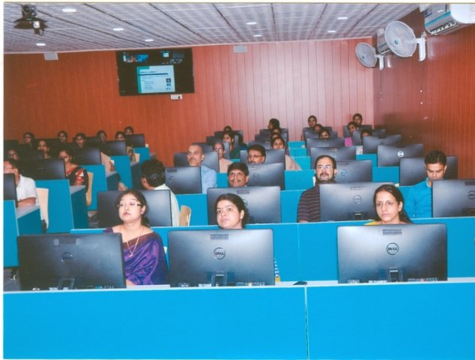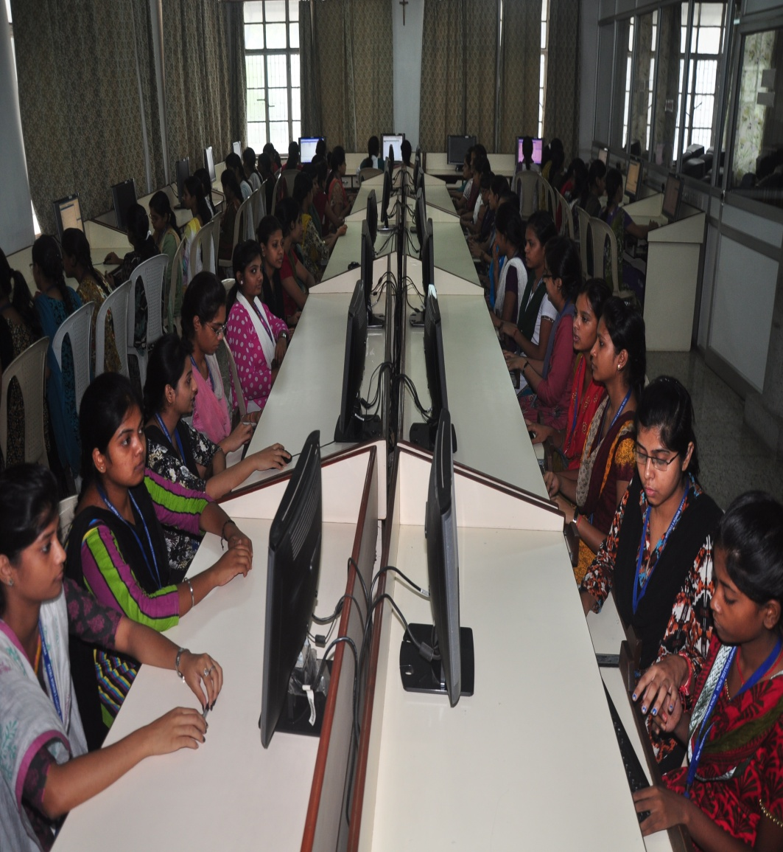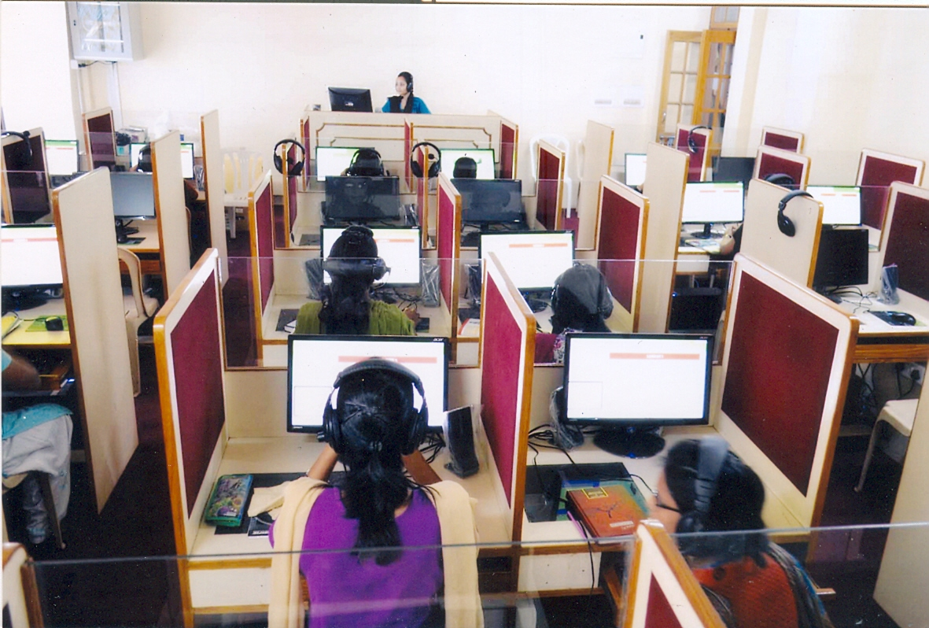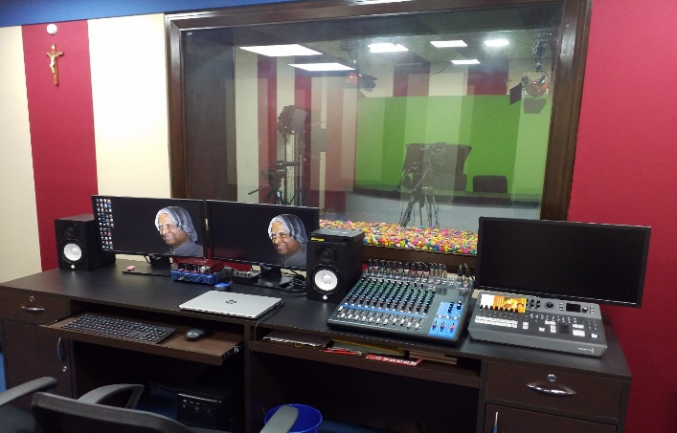

* Android Application Development
* Applied Yoga
* Clinical Nutrition and Dietetics
* Computer Literacy Programme
* Criminology
* English for Career Development
* Financial Accounting
* National Stock Exchange Certified Capital Programme (NCCMP) (only Commerce)
* Human Resource Management
* Human Rights and Values in Education
* Internet of Things
* Office Management
* Public Relations
* Risk and Insurance Management
* Stress Management
* Vermi-biotechnology

**COMPUTER LAB**

**A.V. LAB & E-CONTENT DEV.CENTRE**

**DIGITAL LANGUAGE LAB**

* 3D Animation and Design
* Textile Ornamentation and Home Fashion
* Travel and Tourism Management
* Web Designing
* Women's Studies
* Horticulture and Landscape Gardening
* Data Science
* French Language
* German Language
* Spanish Language
* Korean Language and Culture
* Photography
* Yoga and Education (only B.Ed.)
* Knowledge of India (only B.Ed.)
* Bio-informatics
* Video Editing
* Electrical and Electronic Acquaintance
* Performing Arts (15 Credits)

**Add-on Advanced Diploma Course (Credit) Based)**

**Add-on Diploma Course (Credit Based)**

* Applied Yoga
* Human Resource Management
* Public Relations
* Risk and Insurance Management
* Stress Management
* Textile Ornamentation and Home Fashion
* Office Management
* Applied Yoga
* Human Resource Management
* Public Relations
* Risk and Insurance Management
* Stress Management
* Textile Ornamentation and Home Fashion
* Online – Add-on Certificate Course (MOOC’s Courses)

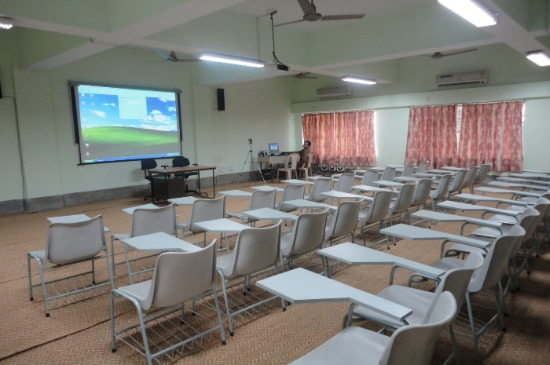

**VERONICA AUDITORIUM**

**VIRTUAL LAB**

**FACILITIES**

* Air-condition Study Hall
* Bank with ATM facility
* Canteen and Cafeteria
* Customised Learning Management System – PWC Link
* Playground and Sports facilities
* Multi-purpose Seminar and Conference Halls
* Prayer Room and Chapel
* Students’ Hostel
* Wi-fi enable Campus
* Generator facility
* Audio visual Lab and E-content Development Centre
* Solar street lighting
* Solar panels for alternative energy
* Creche and Day Care Centre
* A C study Hall
* State of Art Auditorium
* Business Entrepreneurship Incubation and Innovation Centre
* Green and Clean Campus
* Safe Drinking Water and Water Cooler
* Facilities for Specially abled (Divyangjan)
* Library
* Fully Automated RFID Central Library
* e-Library with subscription to reputed Journals and Depositories
* Departmental Library
* High band with Internet connectivity Computer Labs
* Research facility for students
* Central Research Laboratory
* Digital Language Lab
* Health Care Centre
* Alternative Health Care Centre
* Women’s Study Centre
* Well-equipped Science Labs
* Guidance and Counselling Centre
* Publishing House
* Commerce Lab
* Virtual Lab
* Herbal Garden and Vermicomposting Units
* Genetic Nursery and Eco farm
* Guest House
* Video Conferencing Room

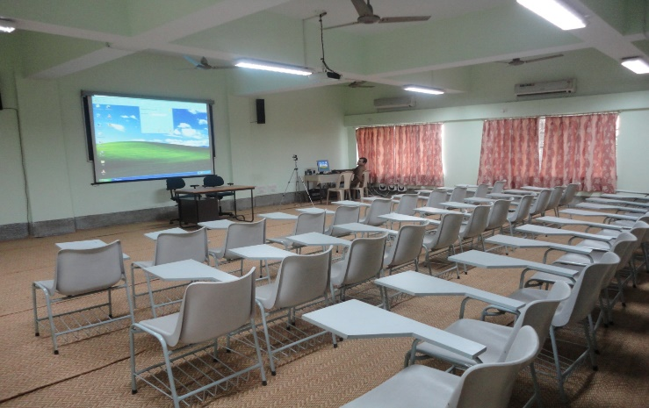

**VIDEO CONFERENCING HALL**

**LUCILE MEMORIAL HALL**

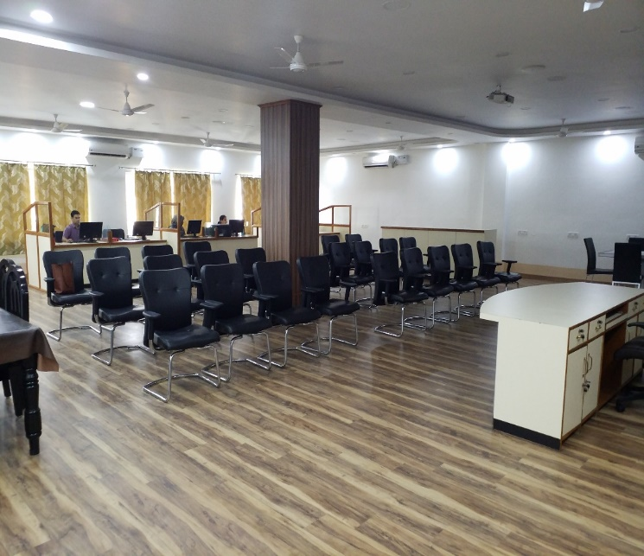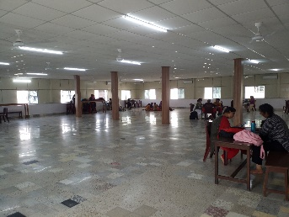

**BENEDICTA MEMORIAL**

**STUDY HALL**

**MOTHER VERONICA EXCELLENCE AND INNOVATION CENTRE**

**CENTRAL RESEARCH LAB (CRL)**

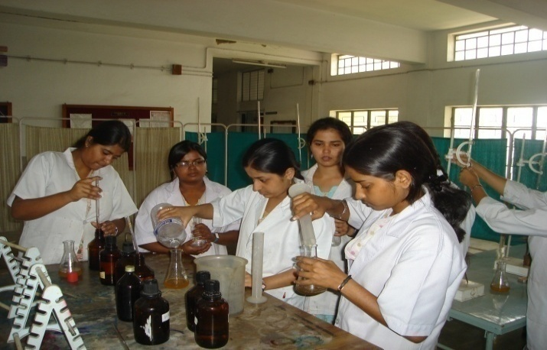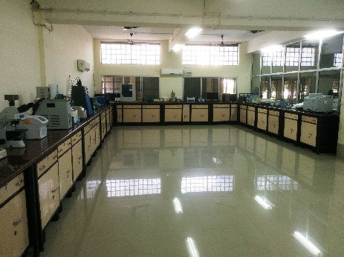

**MICROBIOLOGY LAB**

**CENTRAL RESEARCH LAB (CRL)**

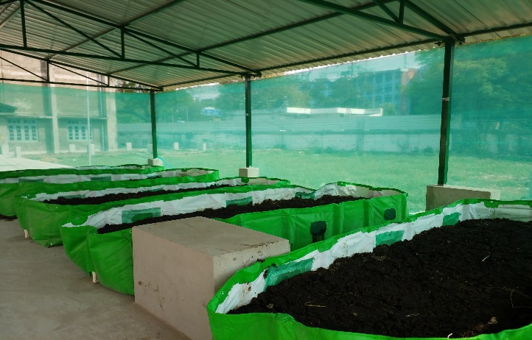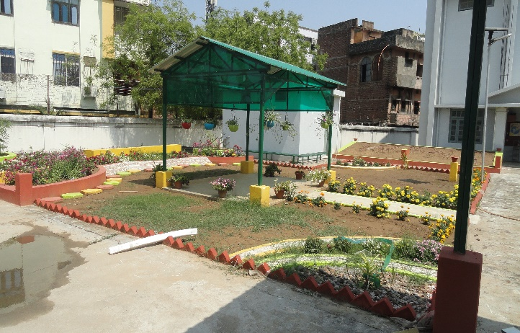

**LANDSCAPE GARDENING**

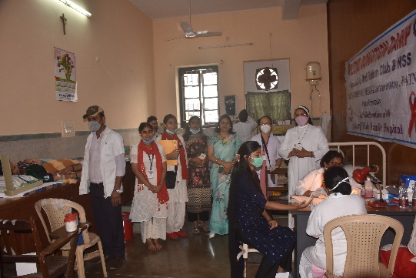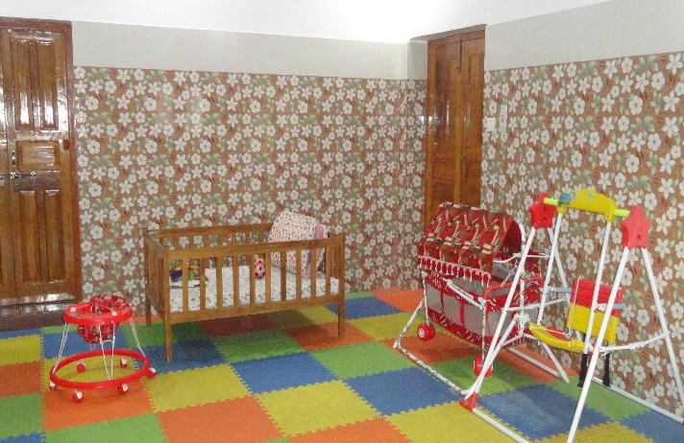

**VERMICOMPOSTING UNITS**

**HEALTH CARE CENTRE**

**CRECHE AND DAY CARE CENTRE**

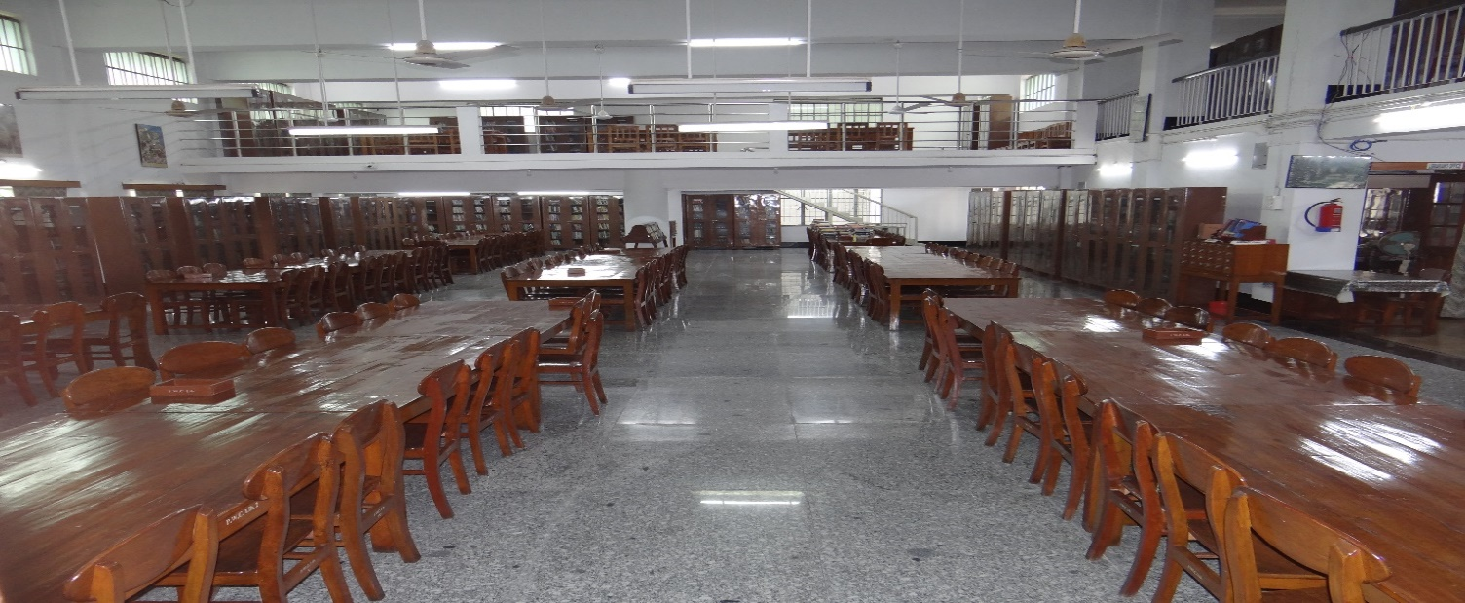

**CENTRAL LIBRARY**

**ACHIEVEMENTS**

* Patna Women’s College is the first College for women in Bihar.
* In 2018, the UGC conferred Autonomy to the College.
* The College is NAAC accredited with CGPA 3.58/4.
* The College has ‘College with Potential for Excellence’ (CPE) status accorded by UGC.
* It has also received “Gurukul Jyoti Award’ for excellence in higher education.
* The College received the Best Lady College award in the year 2019 by Hon’ble Governor of Bihar
* It is ranked at a rank band of 101 - 150 in the NIRF 2021 Ranking under College category
* Patna Women’ College has achieved 1st rank in Arts and 3rd rank in Science in the Eastern zone in the India Today MDRA Best Colleges of India survey, 2022.
* The College has very rich Alumni with extraordinary professional achievements.
* The College has MOU’s with reputed Colleges across the globe.
* The College has collaborated with reputed corporate firms for Campus Recruitments.
* Academic programme are integrated with Outcome Based Education (OBE) approach.

**SCHOLARSHIP**

* The gives Freeship, Scholarships and Concessions to under privilege and deserving students

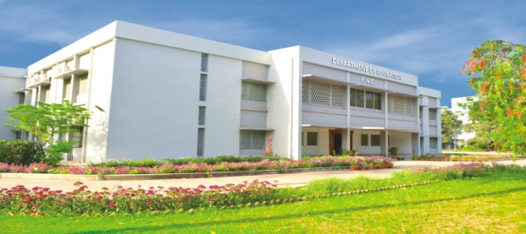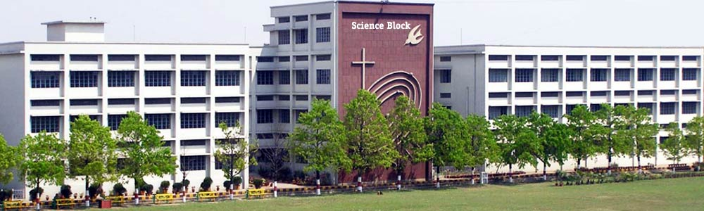

**VERONICA AUDITORIUM**

**SCIENCE BLOCK**

**B.Ed. BLOCK**